Linux Commands:

ll command: this command gives us the long list of the files and directories along with the timestamp. We can identify whether it is a file or a directory by the first character of the permissions.
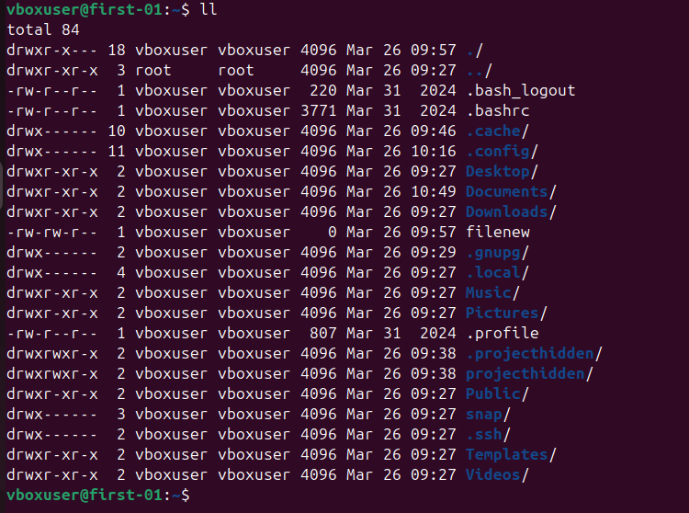

Changing permission of a file:
chmod: this is the command used to change the permissions of a file or a directory.
Eg: 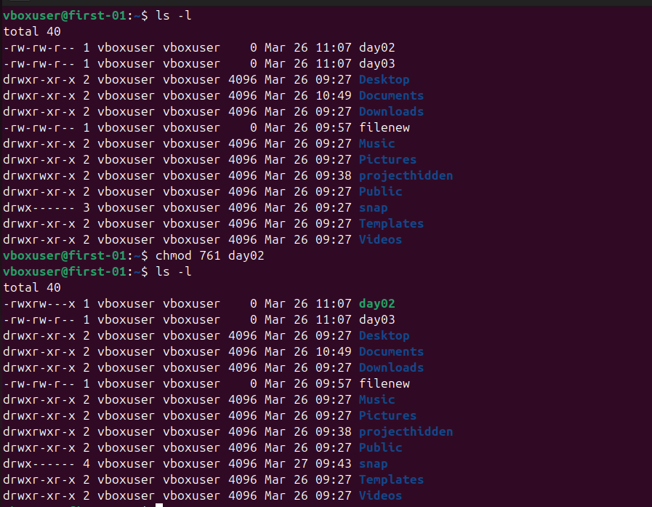
Here I have changed the permission of the day02 file for owner, group and other users.
Before the owner and group had read write permissions and other users had write permission.
After change the owner has read, write and execute permission group has read, write permission and other users have execute permission.

Command to check all the users in linux:
cat /etc/passwd:
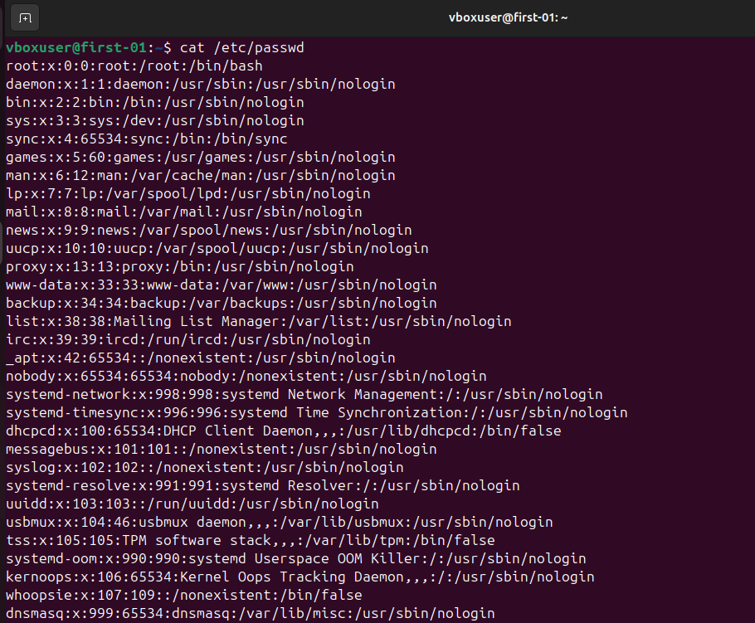

Creating a new user in linux:
useradd is the command to create a new user in linux.
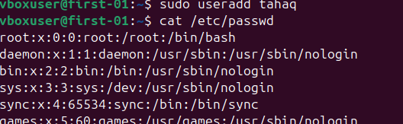
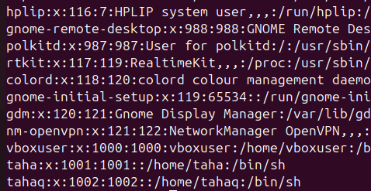
I have created a user named tahaq in the above example.

Adding Password to a user:
passwd is the command to add a password to user.
passwd username
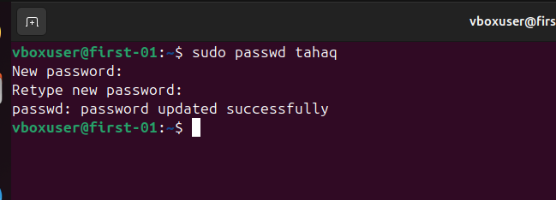
Here I have updated the password for the user tahaq

Switching from one user to another:
su is the command to switch user
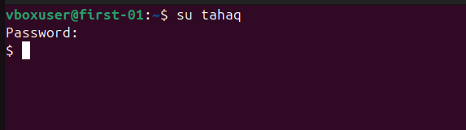
Here I have switched from vboxuser to tahaq user and the dollar represents the sh shell.

Root is the user with the highest privileges which means root user can do anything on a linux machine.
As a user we will not have access to do every task like installing etc for that we need our user to have sudo priveleges.
Currently the user tahaq does not have sudo privileges because it is not in the sudoers file .
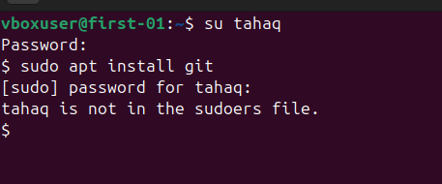
We need to add the user in the sudoers file.
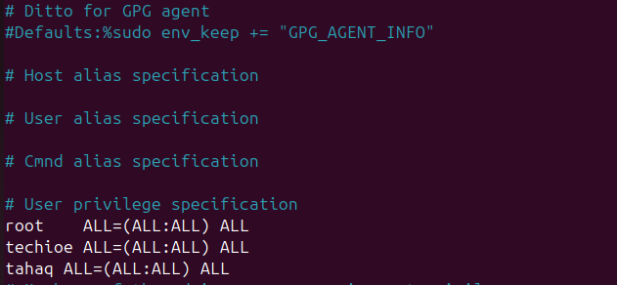

After that we will be able to use commands with sudo previleges
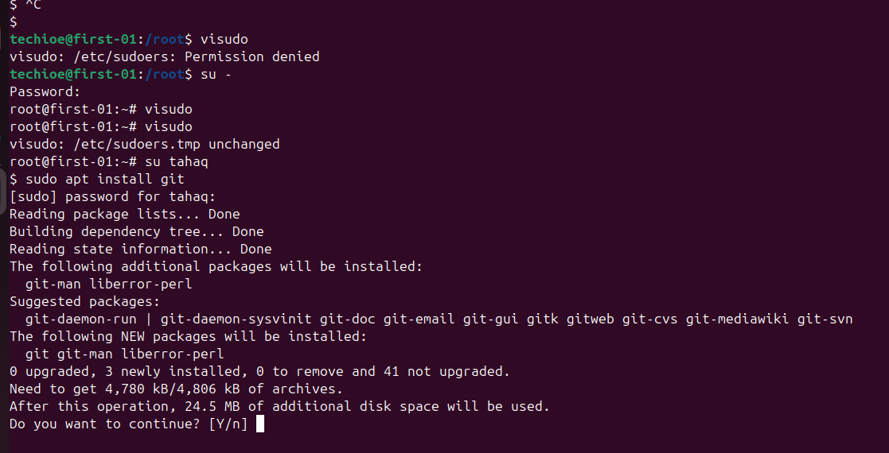
Find Command: This command is used to files or directories in linux
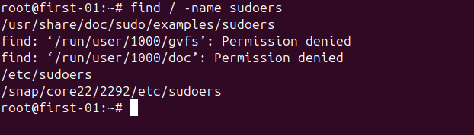
Input and Output Redirection:
Echo command is used to redirect input or output in linux
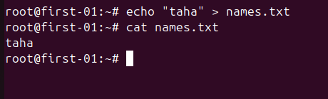
Above is the example of redirection here the file names.txt was not present so the command created the file and added the text. If the file is already present then this command will override the content.
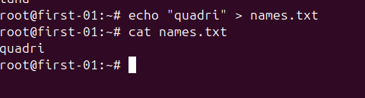
The same command with >> will append the file
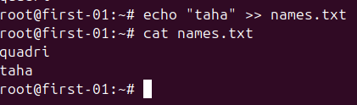

Head Command: this command displays the top few lines of the file based on the parameter given.
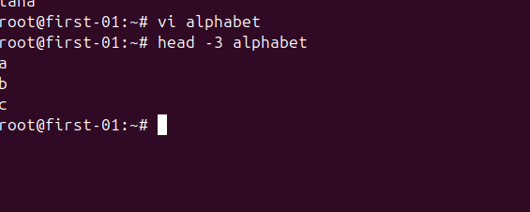

Tail Command : This command displays the last few lines of the file based on the given parameter.
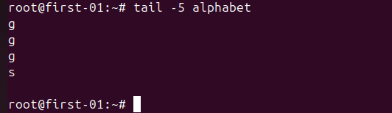

Tail -f command : This command can be used to monitor log files.

Find / -name *.txt : this command allows us to find all the files
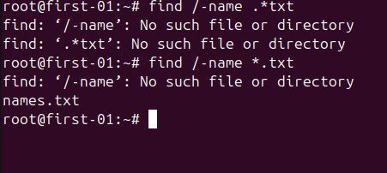
Find / -name file +mtime command : this command allows us to search something by time
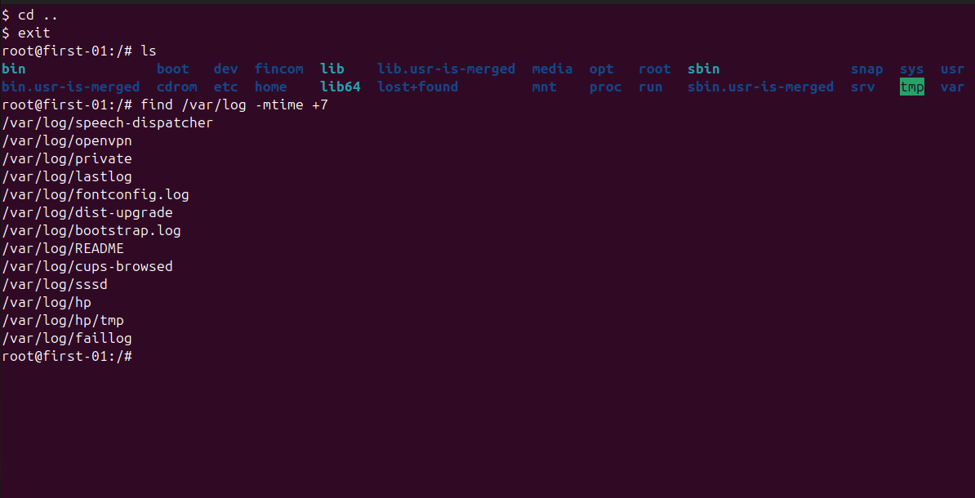

Grep command:
Grep command allows us to check for the specific keywords in a file
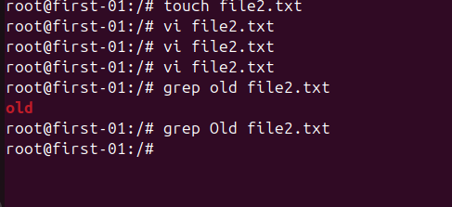

grep -i to check recursively means irrespective of the case the output will be printed.
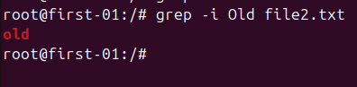
Changing Ownership:
chown is the command to change owner ship in linux:
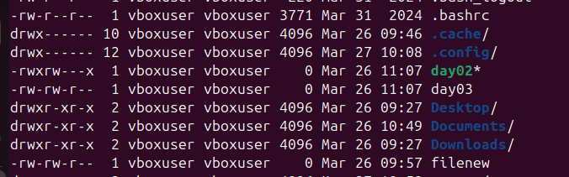

The owner of the filenew is vboxuser currently changing it to root:
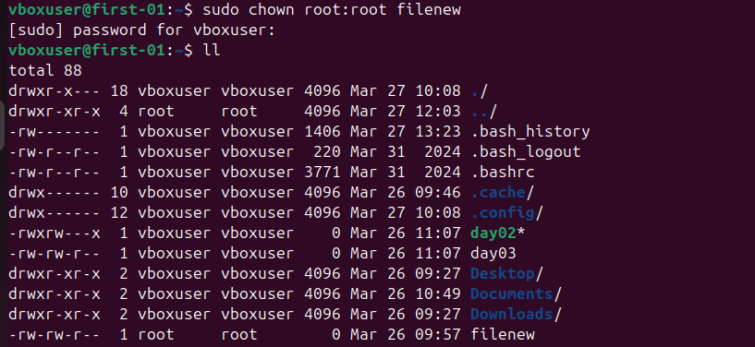
The owner of the filenew is root now.

